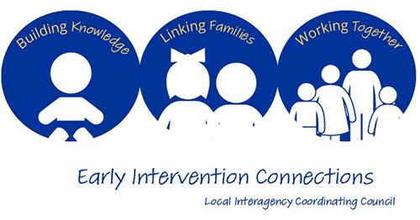
Agenda – Monday 7/24/2023 1-3pm via Zoom

Join Zoom Meeting
https://caiu-org.zoom.us/j/92995637630
Meeting ID: 929 9563 7630
---
One tap mobile
+16465588656,,92995637630# US (New York)
+16469313860,,92995637630# US
---
Dial by your location
• +1 646 558 8656 US (New York)
• +1 646 931 3860 US
Meeting ID: 929 9563 7630
Find your local number: https://caiu-org.zoom.us/u/aetOTDe8r7

- Family story – Sue Bower
- Introductions and agency/family updates
- Review and approval April, 2023 meeting minutes
- Committee Discussions/Tasks
- EIC Carnival discussion/planning – Amy Swartz and Jill Nelson
- Children’s Social-Emotional Development – Brittany Stough & Tammy Shoff
- Transition
- Child Find
- Provider Liaison report – Brittany Stough
- Family Guided Routines Based Intervention (FGRBI) Coaching updates

- Agenda Items
  - Training ideas for family presentations – Fall and Spring
  - Cumberland Perry EI/Cumberland libraries collaboration
  - EIC Promotion – how do we get the word out to EI families and EI staff
  - Resource ideas/families for family stories for upcoming EIC meetings – Parent to Parent presenting at January 2024 meeting.
- State ICC Update

- Adjournment
______________________________________________________________________________________
Next EIC Meetings Dates (all virtual):
10/23 6-8pm
1/22/24 6-8pm
4/22/24 1-3pm

Parent Co-Chair, Xiomara Marquez Professional Co-Chair, Amy Reed Xiomy14_16@hotmail.com Cumberland/Perry MH IDD EI
1615 Ritner Highway
Carlisle, PA 17013
(717)240-6320
amreed@cumberlandcountypa.gov

