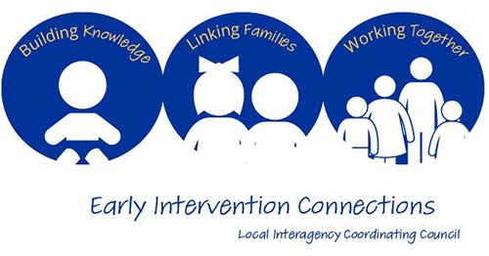
Agenda – Monday 4/22/2024 6-8pm via Zoom

Participants: Marci Walborn, Jackie Wardle, Amanda Neidig, Amy Reed, Amy Swartz, Brittany Stough, Diane Durham-Messner, Gina Federico, Jean Foley, Jeanne Predmore, Kim Barbetta, Marissa Dieter, Susan Stare, Tammy Shoff, Terry Telep

- AAC and Lending Library presentation- UCP of Central PA
- Introductions and updates
- Review and approval January 2024 meeting minutes-will be sent to tonight’s participants.
- Committee Discussions/Tasks
- EIC Carnival discussion/planning – (Amy Swartz and Jill Nelson)-flyers went out today and will continue to go out this week to Infant Toddler and Preschool providers. Event will take place on 6/4 at Adventure Zone Playground; physically located at the Vibrant Church on Lambs Gap Road Mechanicsburg. There are several sub committees that have been meeting monthly since August to plan for this. Safety committee and registration plan for event is set up (2 Spanish interpreters will be available). There is a committee that is working on raffle baskets and seeking donations within the EI community through an Amazon Wishlist. Light Snacks will be available for children. Balloon twisting, face painting and traveling zoo secured for the event. There will be 12 Resource Tables and provider booths. Next meeting is 5/14 at 1PM virtually. Event will be capped at 700.
- Children’s Social-Emotional Development – (Brittany Stough & Tammy Shoff). The committee is focusing on the birth to five year old infant/toddler and preschooler programs in Cumberland, Perry, and Dauphin. The committee has decided to breakout into 3 subcommittees. Tammy Shoff is leading the Family Support Committee and the EI Professionals’ Support Committee. The goal is to provide trainings, outreach, and resources for each and collaborate with their third committee which is the Assessment Committee that Brittany Stough leads. Assessment Committee- always looking for quality improvement for screeners and PHQ9 and ASQ-SE to make sure we have current handouts and resources for
- Transition – (Tammy Shoff) Committee has grown and has included Franklin, Admas, and Northern York providers. Michelle Straw is the contact for the CAIU and Marci Walborn is the contact for providers. CAIU hired a new Data Coordinator, Jennifer Stutzman to send PMUs and QPMs to. Gina Federico, EITA Consultants part of the committee and helps guide the group with trainings and feedback.
- Child Find: Library outreach (Cumberland and Shippensburg), Goddard outreach, Disability Fair in Mechanicsburg, WIC anniversary, Aldersgate Preschool, Coordination with Ready for School Ready to Succeed, EITA Early Intervention I Am Campaign, Insta Gram: did you know
- Provider Liaison report – (Brittany Stough)-no updates
- Family Survey progress – Dauphin IT: 18.96%, Cumberland-Perry IT: 28.34% and CAIU:15.39%

- Agenda Items
  - Upcoming 24-25 EIC meeting dates/times: All meetings will be virtual and take place from 1-3 PM on the following dates: 7/22, 10/28, 1/27 and 4/18

- State ICC Update- we will talk about this in July.

- Adjournment
______________________________________________________________
Next EIC Meetings Date: 7/22 Monday 1-3 PM-virtual https://caiu-org.zoom.us/j/92941123270

Parent Co-Chair, Lauren Pierce Professional Co-Chair, Amy Reed
Lauren5elizabeth@hotmail.com Cumberland Perry MH IDD EI
1615 Ritner Highway
Carlisle, PA 17013
(717)240-6320
amreed@cumberlandcountypa.gov

